*29th Annual*
Car Capital Auto Show Sponsorship Revs Up Lansing
On Saturday, July 30, 2022 the R.E. Olds Transportation Museum’s Car Capital Auto Show motors into Downtown Lansing to provide a premier auto show to the public. Thousands of spectators and up to 200 registered vehicles are anticipated for this year’s event. This free, non-profit, family-friendly event has attracted attention from area residents, as well as people throughout the Midwest.

Sponsorship Opportunities
By partnering with this event you’ll be positioning your company as a community-minded contributor and key supporter of the area’s only cultural car teaching museum. Countless busloads of school children, as well as visitors from around the world visit our displays to learn of our area's rich transportation history. Your participation and influence will not only help the museum, but will be seen by thousands while enhancing tourism to our area.

The R.E. Olds Transportation Museum is a non-profit 501(c)(3) organization and your sponsorship donation may be tax deductible.
Sponsor Levels
Sponsorship Level (see reverse side for benefits)
Title Sponsor $5,000
Platinum $2,500
Gold $1,000
Silver $500
Bronze $250
Ambassador $100
Supporter $50

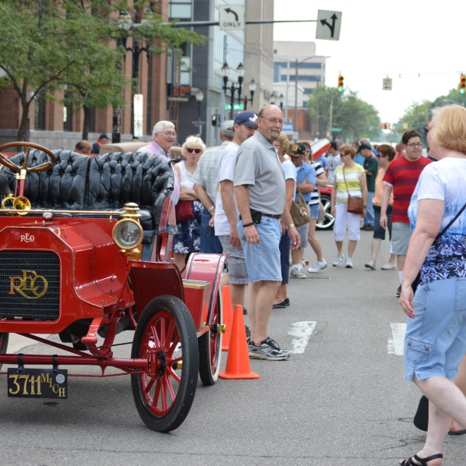
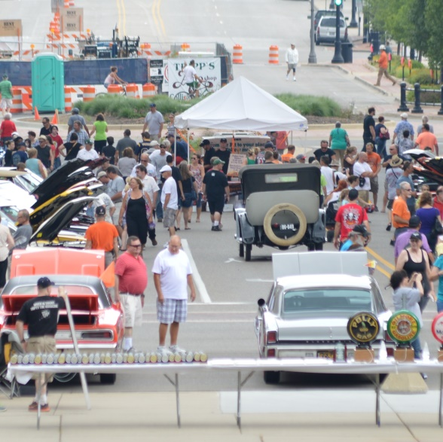
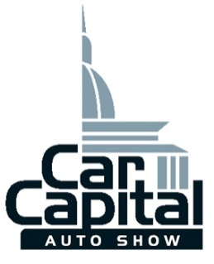
2020
29th R.E. Olds Transportation Museum Car Capital Auto Show
Sponsorship Levels
Title Sponsor: $5000- All benefits from levels below plus
- 10x10 sponsor space with tent now to be adjacent to the awards table, at the center of the show.
- Special award designed for your company, and presented at the event by your representative.
- Your company name engraved on 1 or more Best in Show Awards.
Platinum Level: $2500- All benefits from levels below plus
- 10x10 sponsor space with tent at the center of the show.
- Recognition on radio promotional spots on local broadcasts.
Gold Level: $1000- All benefits from levels below plus
- 10x10 sponsor space on the show field (you provide tent)
- Your name AND logo printed on flyer for next year’s show.

Silver Level: $500- All benefits from levels below plus
- Recognition on the R.E. Olds Transportation Museum website WITH a direct link to your site.
- Your company name announced throughout the day at the event.
- Your name printed on flyer for next year’s show.

Bronze Level: $250- Benefits from levels below plus
- Recognition on both the Museum’s and the dedicated car show Facebook page as a Bronze Level Sponsor.
- Your company name PLUS logo on sponsorship board.
- Opportunity to distribute promotional material to show attendees.
Ambassador Level: $100- Benefits from level below plus
- Your company name on the sponsorship board.

Supporter Level: $50
- Recognition on the Car Capital Auto Show website.

In-Kind Donations: If you have an in-kind donation that would be beneficial to the show, please call the Museum at 517-372-0529. (Vendor spaces also available)

To become a sponsor, complete this form and mail to:
R.E. Olds Transportation Museum, 240 Museum Drive, Lansing, MI 48933

Please select a level of sponsorship: _________________
Company Name: ________________________________
Contact Person: ________________________________ Email: ________________________________
Address: ______________________________________________________________________________
Phone Number: _________________________________ Fax Number: __________________________
Please select a method of payment:
☐Check enclosed, made payable to R.E. Olds Transportation Museum
☐Credit Card (circle one): MC VS Dis
Credit Card #: ______________________________________
Expiration Date: ___________ CCV# ___________ Signature: ________________________________
Questions? Contact Scott Mrdeza, Executive Director at (517) 372-0529 director@reoldsmuseum.org

